
DEPARTMENT OF ELECTRONICS AND COMMUNICATION ENGINEERING
Advanced short circuit preventive mechanism for Electric vehicles
Dr.K.SHEIKDAVOOD,M.E.,Ph.D.(AP/ECE)
Yasar S, RK Shanjay, M Sivaramakrishnan, P Subash
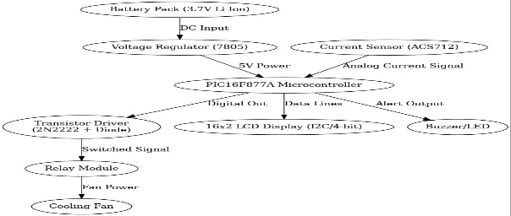
BLOCK DIAGRAM APPLICATION
                - Electric Vehicle Safety Systems
                - Autonomous & Connected Vehicles
                - Battery Energy storage System (BESS)
ADVANTAGES
                - Real-time fault response
                - Predictive maintenance analytics
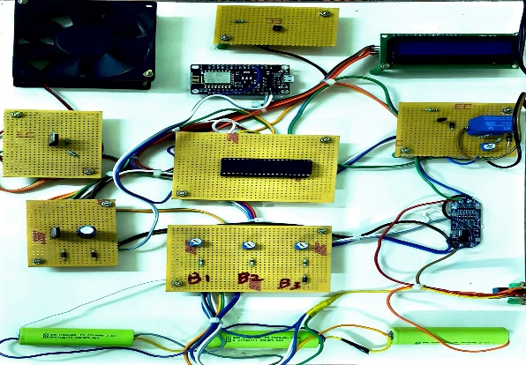
                - Automated fault isolation
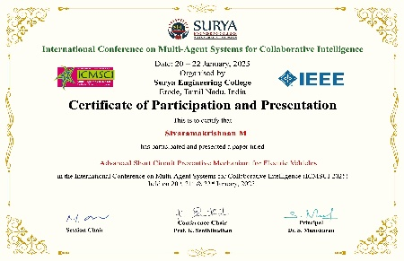
OUTCOME CONFERENCE

